DIGITAL SIGNATURES

CREATING AND VALIDATING SECURE ELECTRONIC DOCUMENTS

SECURING ELECTRONIC DOCUMENTS

  Digital signatures can be used by design professionals (Architects and Engineers)
to authenticate the electronic documents they create for submittal to a permitting authority.

◆ This method of authenticating documents is authorized by the respective licensing boards by Administrative Rule

◆ Architects 61G1-16.005

  Engineers 61G15-23.003

BOAF / AIA-FLORIDA / FES JOINT TASK FORCE

61G1-16.005

  61G1-16.005 Procedures for Signing and Sealing Electronically Transmitted Plans,
Specifications, Reports or Other Documents.

  (1) Information stored in electronic files representing plans, specifications, plats, reports, or other documents which must be sealed under the provisions of Chapter
481, F.S., shall be signed, dated and sealed by the architect or interior designer in responsible charge.

◆ (a) A scanned image of an original signature shall not be used in lieu of a digital or
electronic signature.

  (b) The date that the electronic signature file was created or the digital signature was placed into the document must appear on the document in the same
manner as date is required to be applied when a licensee uses the manual sealing
procedure set out in Rule 61G1-16.003, F.A.C.

BOAF / AIA-FLORIDA / FES JOINT TASK FORCE

61G1-16.005

  (2) An architect or interior designer utilizing a digital signature to seal construction documents shall assure that the digital signature is:

  (a) Unique to the person using it;

◆ (b) Capable of verification;

◆ (c) Under the sole control of the person using it; and

  (d) Linked to a document in such a manner that the electronic signature is invalidated if any data in the document are changed.

BOAF / AIA-FLORIDA / FES JOINT TASK FORCE

61G15-23.003

◆ 61G15-23.003 Procedures for Signing and Sealing Electronically Transmitted Plans,
Specifications, Reports or Other Documents.

◆ (1) Engineering work which must be sealed under the provisions of Section 471.025, F.S., may be signed electronically or digitally as provided herein by the professional engineer in responsible charge. As used herein, the terms “digital signature” and “electronic signature” shall have the meanings ascribed to them in Sections 668.003(3) and (4), F.S. The affixing of a digital or electronic signature to engineering work as provided herein shall constitute the sealing of such work.

◆ (a) A scanned image of an original signature shall not be used in lieu of a digital or electronic signature.

◆ (b) The date that the electronic signature file was created or the digital signature was placed into the document must appear on the document in the same manner as date is required to be applied when a licensee uses the manual sealing procedure set out in Rule 61G15-23.002, F.A.C.

BOAF / AIA-FLORIDA / FES JOINT TASK FORCE

61G15-23.003

  (2) A professional engineer utilizing a digital signature to seal engineering work shall assure that the digital signature is:

  (a) Unique to the person using it;

◆ (b) Capable of verification;

◆ (c) Under the sole control of the person using it;

  (d) Linked to a document in such a manner that the electronic signature is invalidated if any data in the document are changed.

BOAF / AIA-FLORIDA / FES JOINT TASK FORCE

DIGITAL SIGNATURES

  A key point to remember is that a digital signature is only valid when the associated electronic document (digital file) can be authenticated with the signee’s public key

◆ A paper printout of a digitally signed electronic document cannot be validated, and therefore cannot be used as an official record

◆ A digital signature must be created using key pair technology in accordance with the federal Secure Hash Standard also known as Federal Information Processing Standards, FIPS 180-3 or FIPS 180-4

BOAF / AIA-FLORIDA / FES JOINT TASK FORCE

HOW DIGITAL SIGNATURES WORK

  Digital signature technology is defined in Florida Statutes 668, using one of several algorithms to encode a signee’s personal information, making it possible to authenticate the signature using the Encryption key produces

◆ PDF management software such as Adobe Acrobat or BlueBeam can be used to decode the signature, authenticate the signature and read the history of the file to determine if the file has been changed since the document was signed

BOAF / AIA-FLORIDA / FES JOINT TASK FORCE

FLORIDA STATUTE 668

  As used in this act:

  (1) “Certificate” means a computer-based record which:

◆ | (a) | Identifies the certification authority.
◆ | (b) | Identifies the subscriber.
◆ | (c) | Contains the subscriber’s public key.
◆ | (d) | Is digitally signed by the certification authority.

BOAF / AIA-FLORIDA / FES JOINT TASK FORCE

FLORIDA STATUTE 668

◆ (2) “Certification authority” means a person who issues a certificate.

◆

◆ (3) “Digital signature” means a type of electronic signature that transforms a message using an asymmetric cryptosystem such that a person having the initial message and the signer’s public key can accurately determine:

◆ (a) Whether the transformation was created using the private key that corresponds
to the signer’s public key.

◆ (b) Whether the initial message has been altered since the transformation was
made.

◆ A “key pair” is a private key and its corresponding public key in an asymmetric
cryptosystem, under which the public key verifies a digital signature the private key

BOAF / AIA-FLORIDA / FES JOINT TASK FORCE

FLORIDA STATUTE 668

  (3) “Digital signature” means a type of electronic signature that transforms a message using an asymmetric cryptosystem such that a person having the initial message and the signer’s public key can accurately determine:

◆ (a) Whether the transformation was created using the private key that
corresponds to the signer’s public key.

◆ (b) Whether the initial message has been altered since the transformation was made.

BOAF / AIA-FLORIDA / FES JOINT TASK FORCE

FLORIDA STATUTE 668

  A “key pair” is a private key and its corresponding public key in an asymmetric cryptosystem, under which the public key verifies a digital signature the private key creates. An “asymmetric cryptosystem” is an algorithm or series of algorithms which provide a secure key pair.

BOAF / AIA-FLORIDA / FES JOINT TASK FORCE

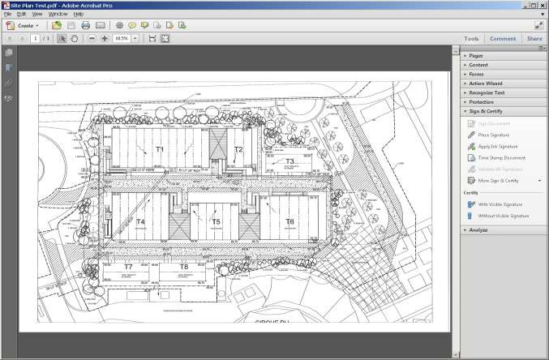

CREATING A SIGNATURE

◆ To create a digital signature, open the “Tools” panel and select “Visual Signature”

BOAF / AIA-FLORIDA / FES JOINT TASK FORCE

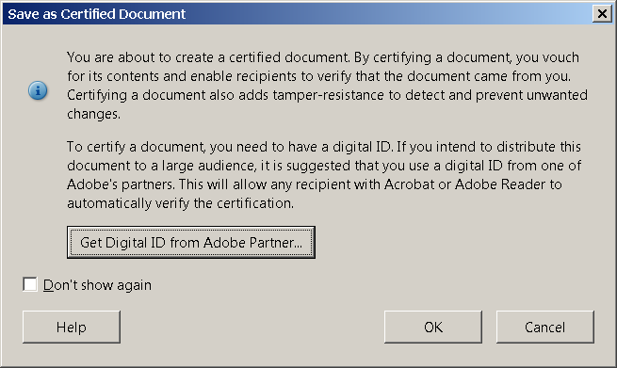

CREATING A SIGNATURE

Click on “OK” at the first screen

BOAF / AIA-FLORIDA / FES JOINT TASK FORCE

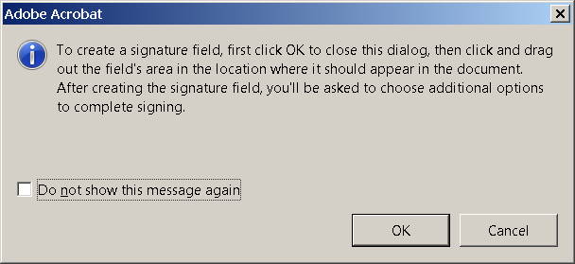

CREATE A SIGNATURE

  Click “OK” to create a signature
field.

BOAF / AIA-FLORIDA / FES JOINT TASK FORCE

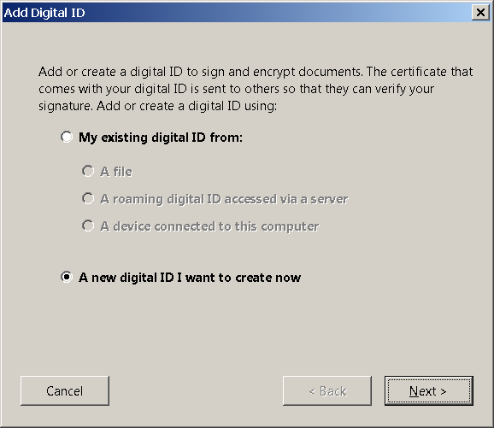

CREATING A SIGNATURE

◆ After the signature field is created the signature file can be selected, or a new signature can be created.

  Note that you only have to signature file is created a signature once

◆ Select “New Digital ID” to create
your signature

BOAF / AIA-FLORIDA / FES JOINT TASK FORCE

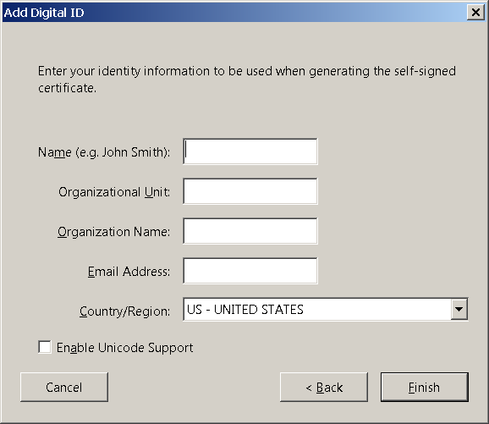

CREATING A SIGNATURE

  Fill in all of the open fields and
click “Finish”

BOAF / AIA-FLORIDA / FES JOINT TASK FORCE

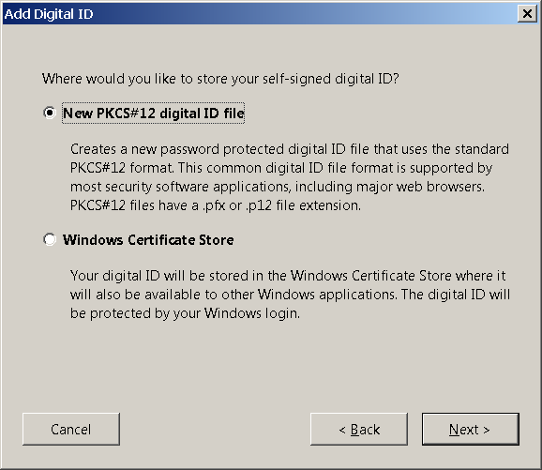

CREATING A SIGNATURE

  To create a password protected Digital ID select “New PKCS#12 digital ID File” and click Next

BOAF / AIA-FLORIDA / FES JOINT TASK FORCE

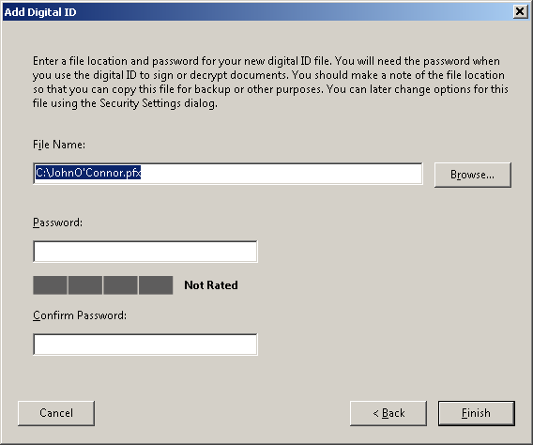

CREATING A SIGNATURE

  The file name will pre-load

  Create a password and confirm

  Click “Finish”

BOAF / AIA-FLORIDA / FES JOINT TASK FORCE

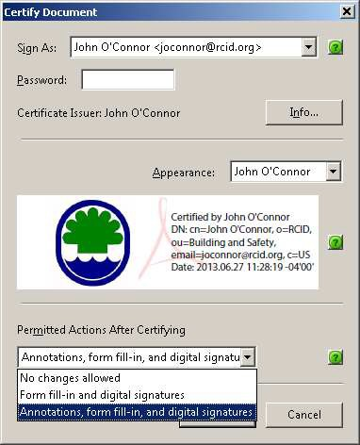

CREATING A SIGNATURE

◆ Now your digital ID has been created and can be used to certify the document

  The top line is your signature file
name; It will auto-load

  On the second line fill in your password

  The third line is the name of the visible
signature, it will auto-load

◆ The fourth line will auto load the signature info

BOAF / AIA-FLORIDA / FES JOINT TASK FORCE

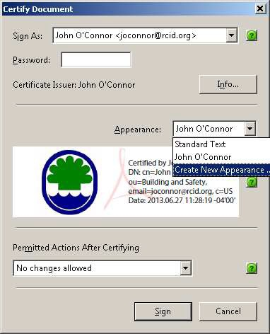

CREATING A SIGNATURE

  Open the drop-down list and select choose new Appearance

BOAF / AIA-FLORIDA / FES JOINT TASK FORCE

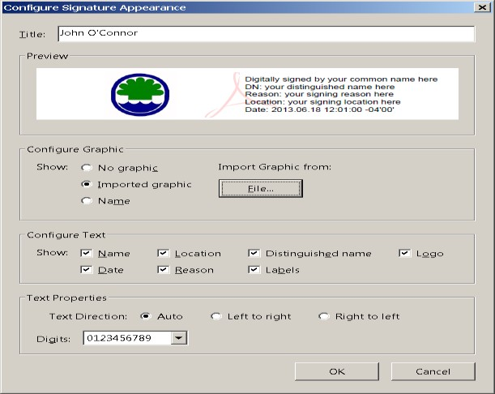

CREATING A SIGNATURE

  Name the signature

  Edit the fields as needed

  Import an image

BOAF / AIA-FLORIDA / FES JOINT TASK FORCE

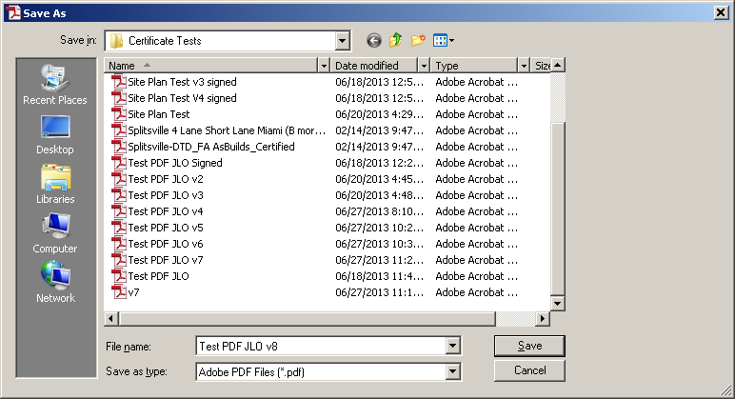

CREATING A SIGNATURE

  Before the signature is added the file must be saved

BOAF / AIA-FLORIDA / FES JOINT TASK FORCE

CREATING A SIGNATURE

  Before the signature is added the file must be saved

BOAF / AIA-FLORIDA / FES JOINT TASK FORCE

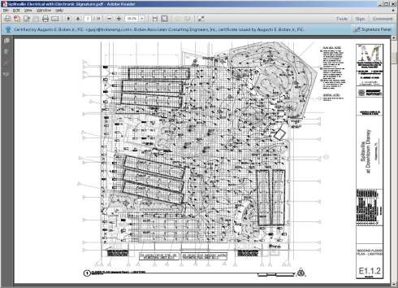

VALIDATING A SIGNATURE

The most commonly used PDF reader is ADOBE Arobat. With their free PDF reader it is possible to view file content, see the document history and validate digital signatures

When a drawing file is opened with Adobe Acrobat, the program will indicate if it has been digitally signed by showing the signature panel button in the right side of the tray above the drawing

BOAF / AIA-FLORIDA / FES JOINT TASK FORCE

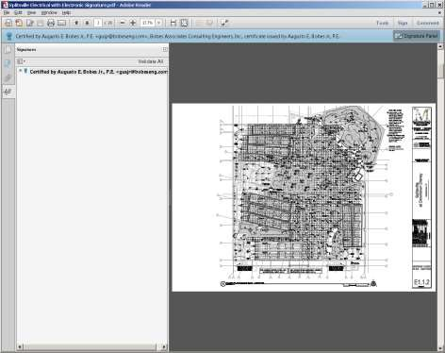

VALIDATING A SIGNATURE

  Click on the Signature Panel button to open the signature panel

  The name of the signee will be
shown

BOAF / AIA-FLORIDA / FES JOINT TASK FORCE

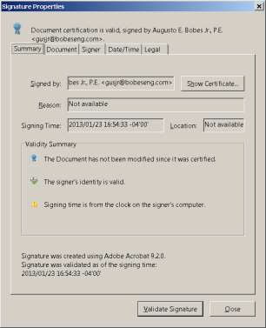

VALIDATING A SIGNATURE

  From the Signature Properties panel click on the Show Certificate button

BOAF / AIA-FLORIDA / FES JOINT TASK FORCE

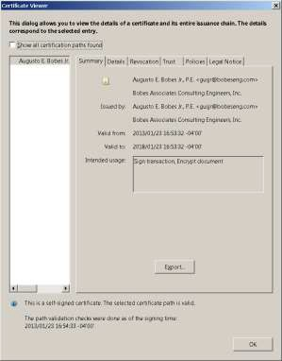

EXPORTING A PUBLIC KEY

  The signee must send the public key to the Authority Having Jurisdiction

◆ This is done by exporting the public key

◆ The Authority Having Jurisdiction must receive the public key and save it in the adobe trusted certificate folder

BOAF / AIA-FLORIDA / FES JOINT TASK FORCE

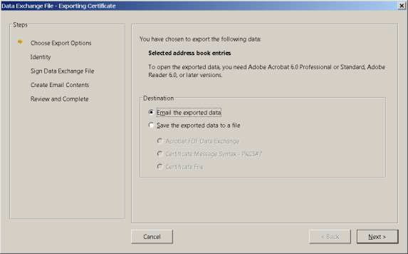

EXPORTING A PUBLIC KEY

  Click on the Export the encrypted data line and then the next button

BOAF / AIA-FLORIDA / FES JOINT TASK FORCE

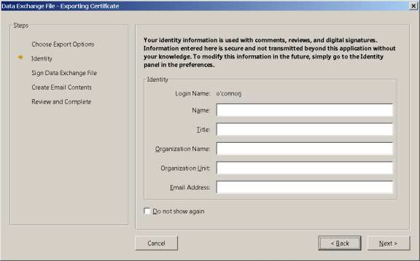

EXPORTING A PUBLIC KEY

  Fill in the information and click the next button

BOAF / AIA-FLORIDA / FES JOINT TASK FORCE

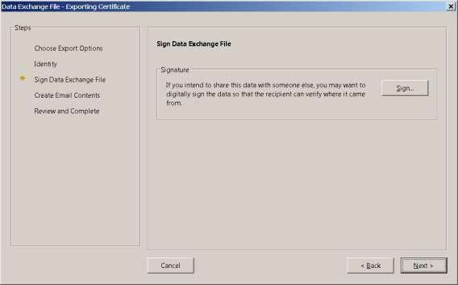

EXPORTING A PUBLIC KEY

  Skip the sign the file option and click next

BOAF / AIA-FLORIDA / FES JOINT TASK FORCE

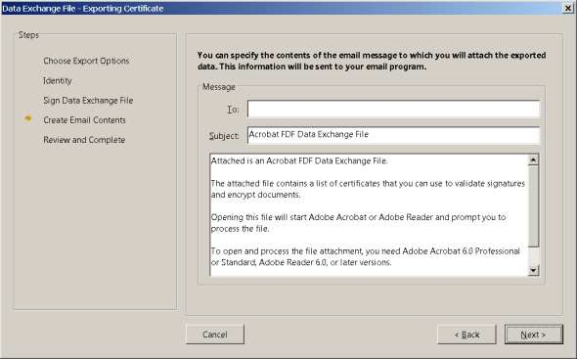

EXPORTING A PUBLIC KEY

  Address the file to the Authority Having Jurisdiction and click next

BOAF / AIA-FLORIDA / FES JOINT TASK FORCE

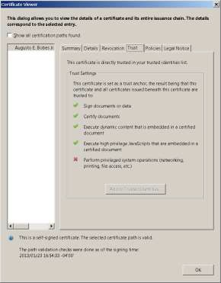

TRUSTING A CERTIFICATE

  Select the Trust tab and check all of the trust settings

  Click on the trust button

BOAF / AIA-FLORIDA / FES JOINT TASK FORCE

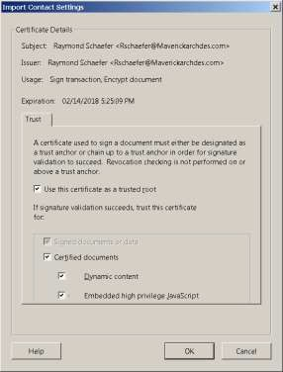

TRUSTING A CERTIFICATE

  Check the content boxes

  Click on the Ok button

BOAF / AIA-FLORIDA / FES JOINT TASK FORCE

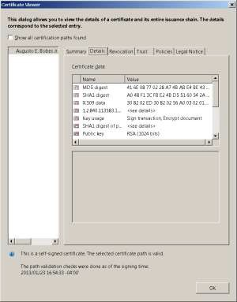

VIEWING SIGNATURE DETAILS

  Open the Details tab to view information about the signature

BOAF / AIA-FLORIDA / FES JOINT TASK FORCE

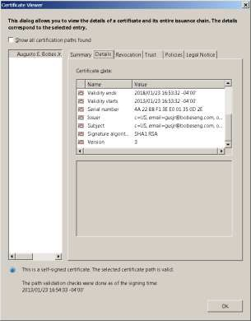

VIEWING SIGNATURE DETAILS

  Move the slide down to view more information

BOAF / AIA-FLORIDA / FES JOINT TASK FORCE

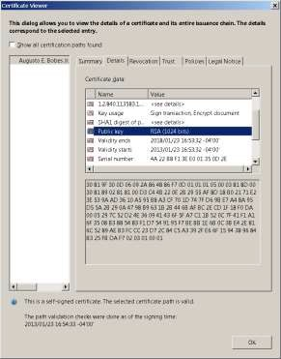

VIEWING SIGNATURE DETAILS

  The public key can be seen by highlighting the Public Key line

BOAF / AIA-FLORIDA / FES JOINT TASK FORCE

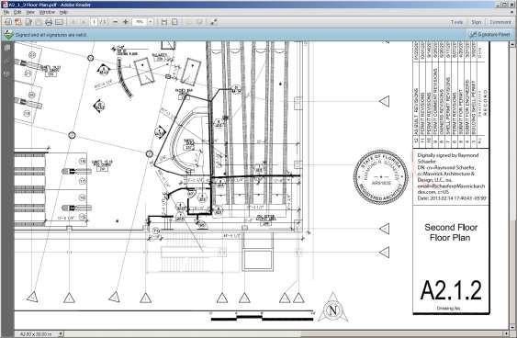

VISIBLE SIGNATURE IMAGES

◆ A visible signature image is not required in the validation process

  However, a visible signature image created by the signature software is helpful to notify the reviewer that the document is digitally signed

◆ A visible signature will contain information required by the rules

BOAF / AIA-FLORIDA / FES JOINT TASK FORCE

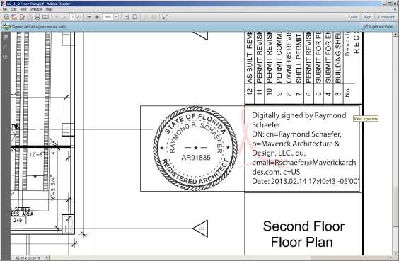

VISIBLE SIGNATURE IMAGES

  A proper visible image can include an image of the signee’s seal, the name of the signee, date, contact information, and the phrase “Digitally signed by…”

BOAF / AIA-FLORIDA / FES JOINT TASK FORCE

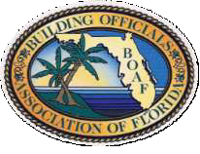

THANK YOU FOR ATTENDING

BOAF / AIA-FLORIDA / FES JOINT TASK FORCE

