To make an online payment for Code Citations and Magistrate Orders on the City’s website: www.cityofmarcoisland.com
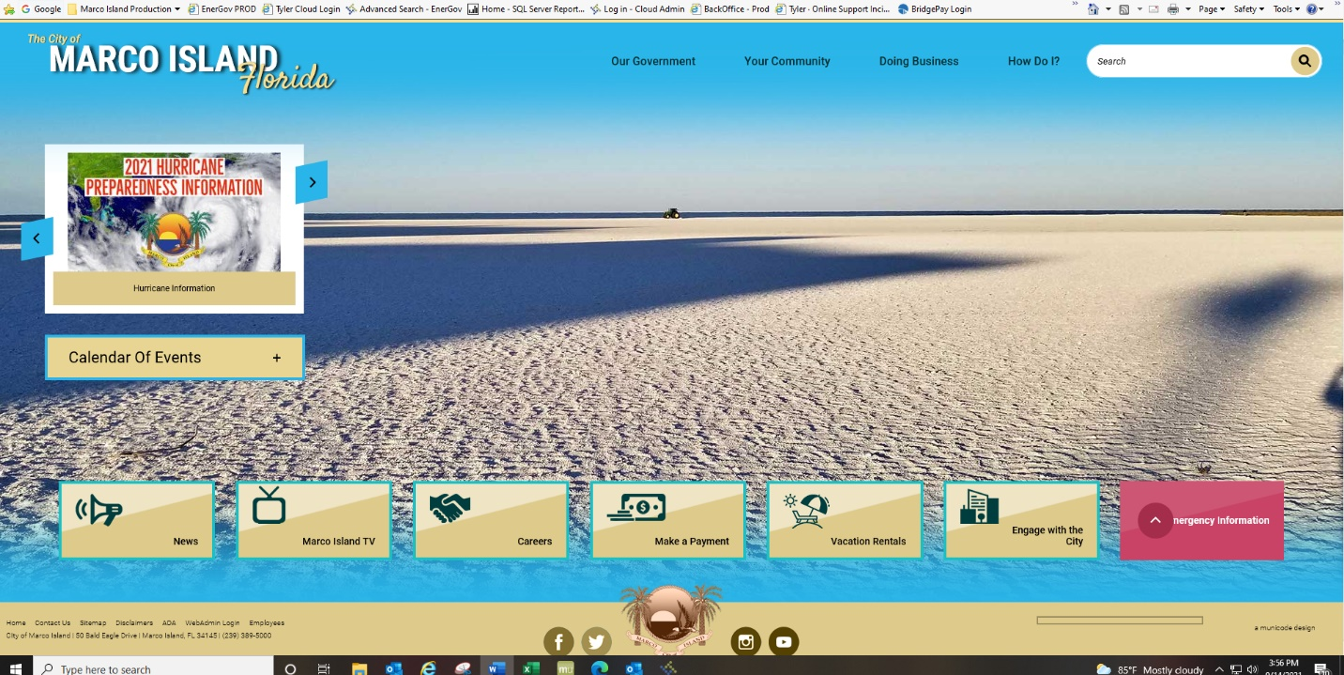
Click on Make a payment

Click on the link
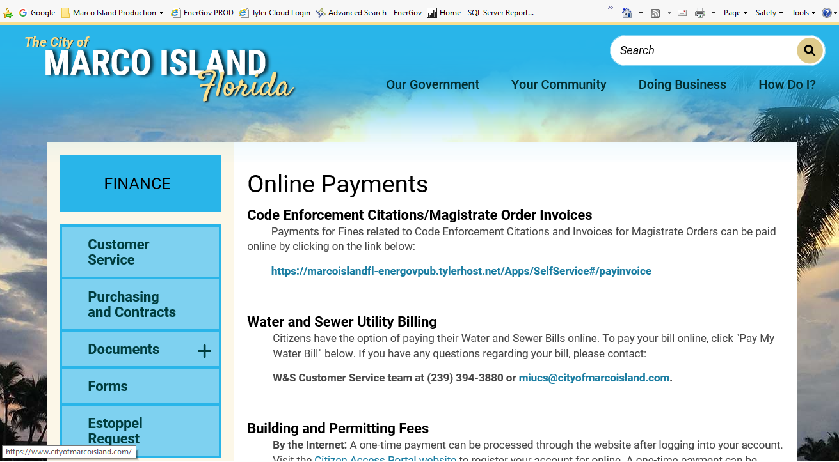

Click on Search

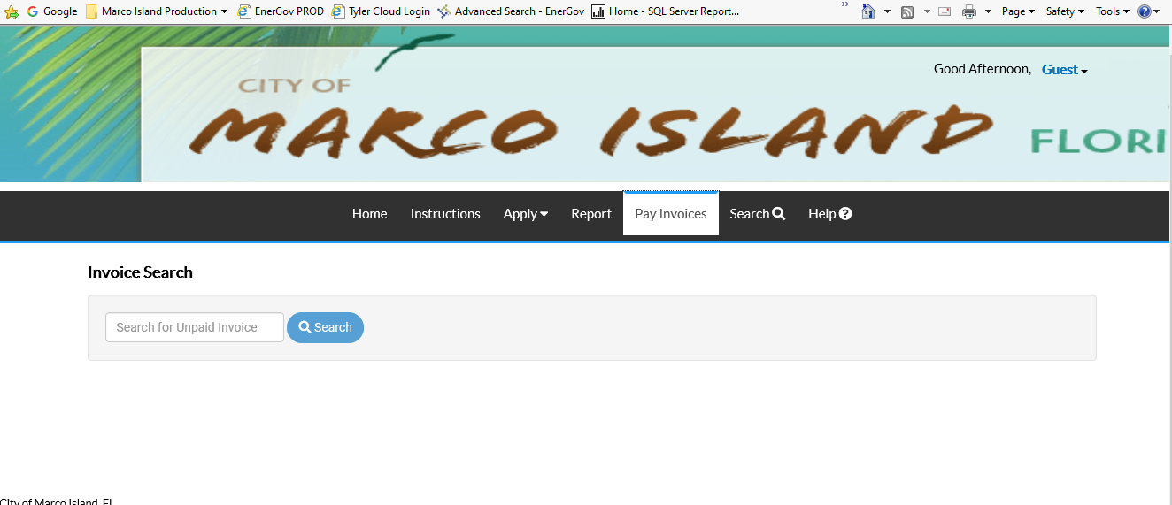

In the Search keywords and addresses field enter the Citation number exactly as it appears on the Citation and hit search.
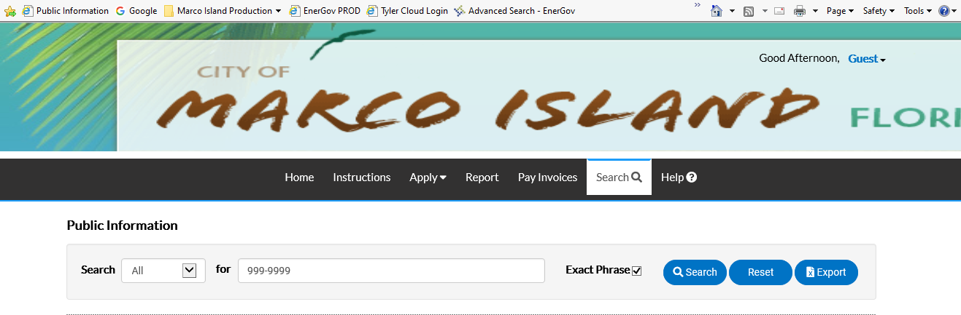

The next screen to display will contain the invoice number associated with the citation.
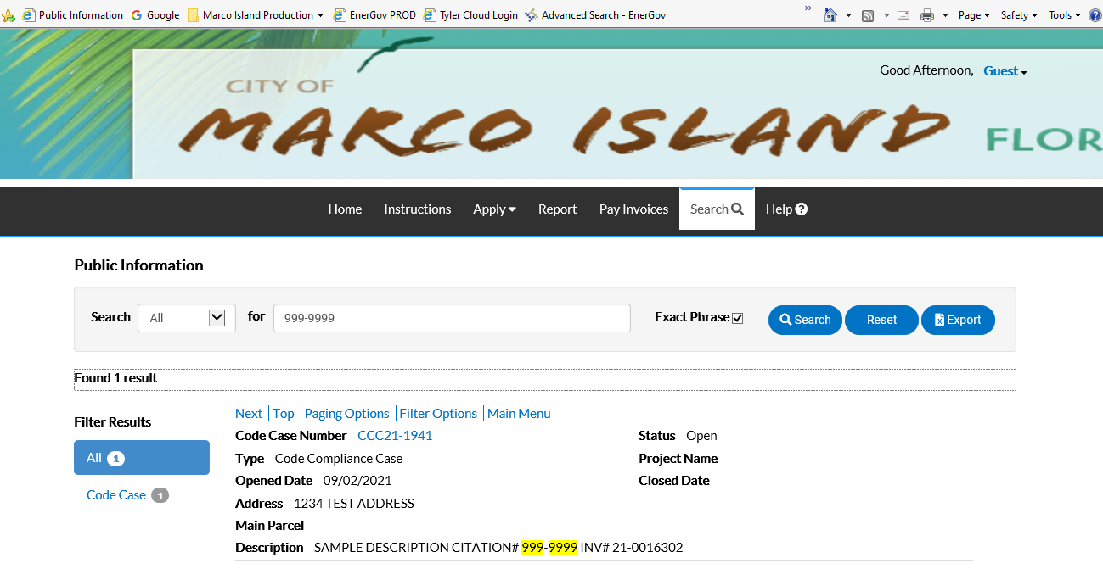

Jot down the invoice number and click on Pay Invoices
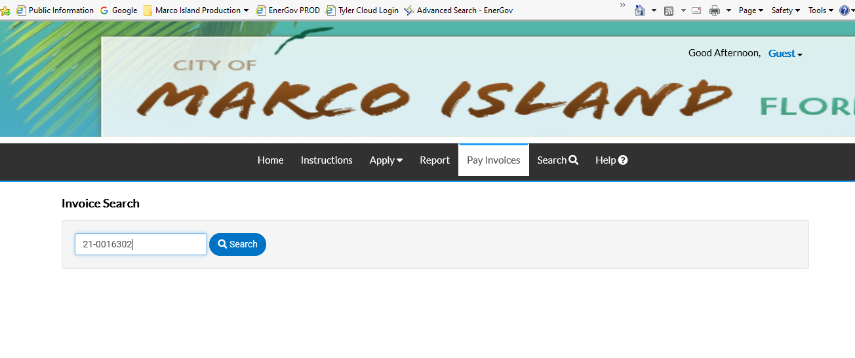
In the Search field enter the invoice number and click on Search
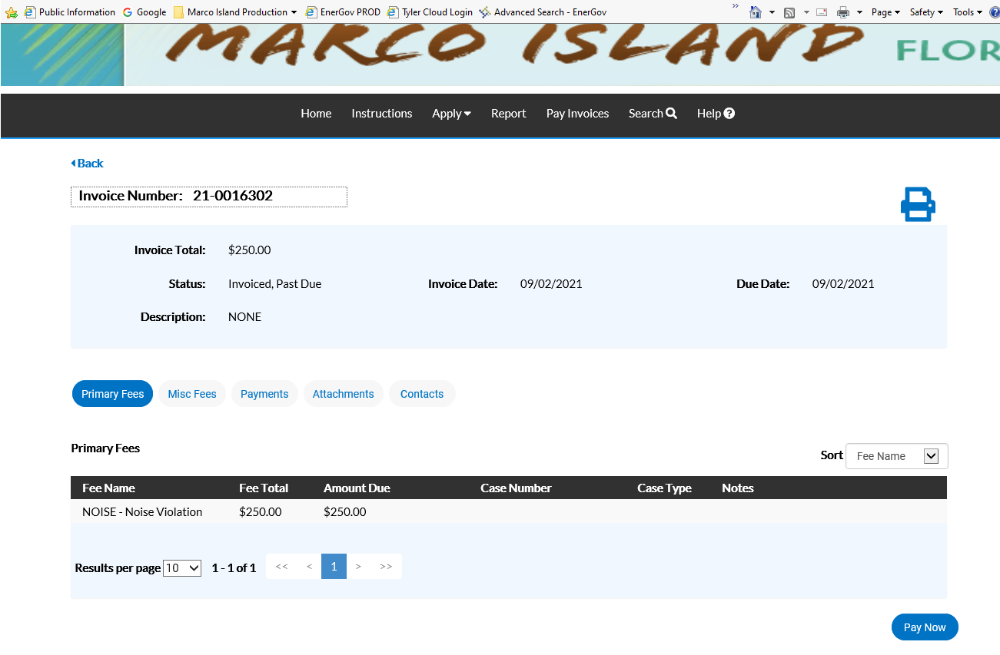
Click on Pay now and follow the instructions.

