Setting Up Online Billing Paying/Linking Account
- Go to the City’s Website www.cityofmarcoisland.com
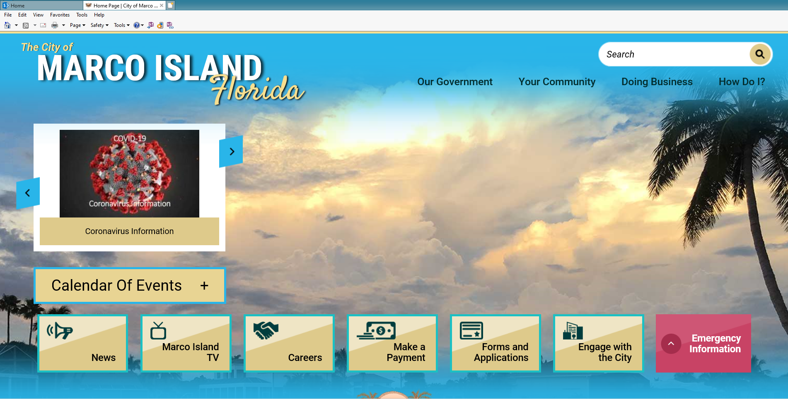
- Click on link “Make a Payment”
- Click on link “Pay May Water Bill”
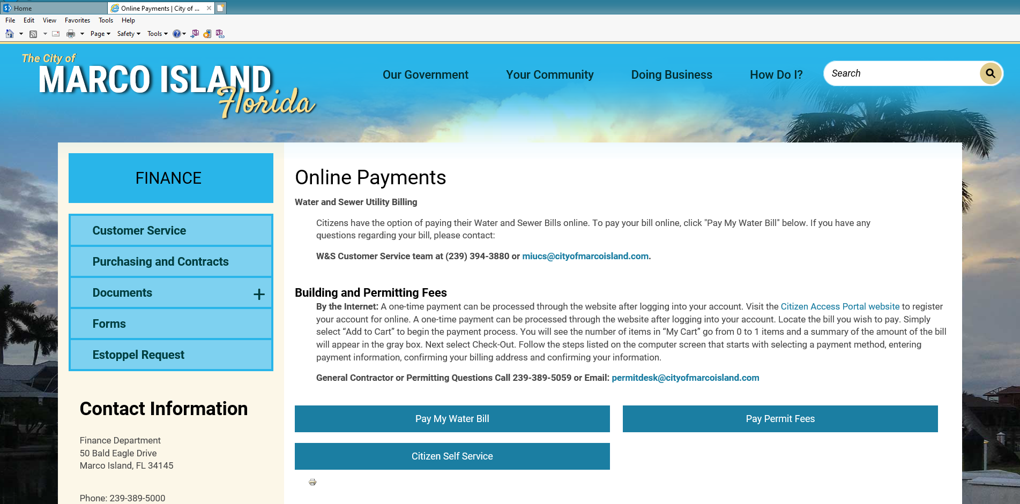

- Click on link “Pay online via our SELF-SERVICE”
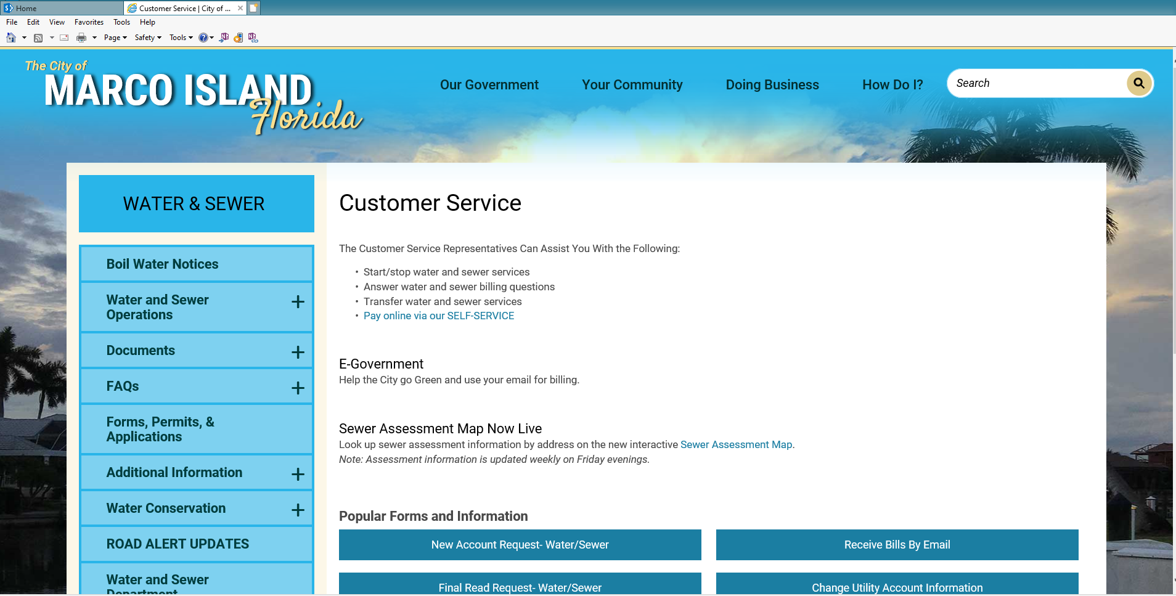
- Click on link “Register”
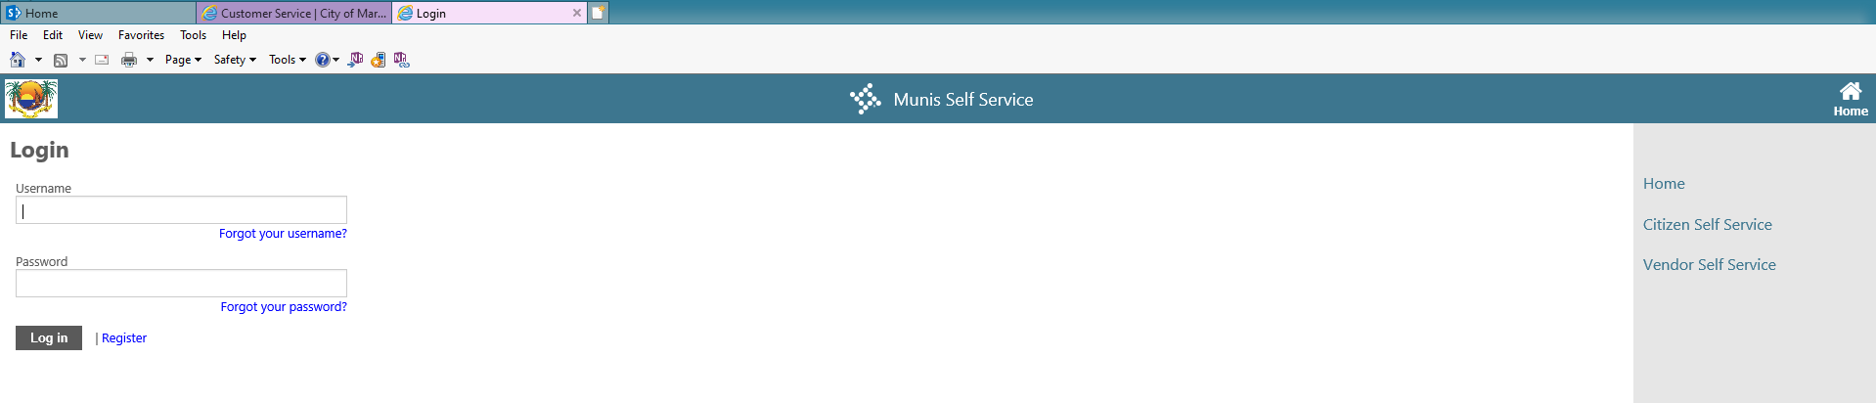
- Create your own unique User ID, Password, Password Hint, etc., click Save
- On the right hand side under Citizen Self Service click on “Utility Billing”
- Next to Utility Billing Accounts – Click “Link to Account”
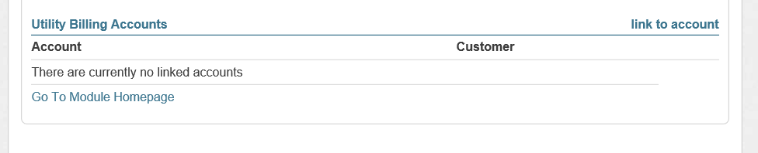
- Enter your 5 digit Account ID
- Enter your 6 digit Customer Identification (CID)
- Click Submit
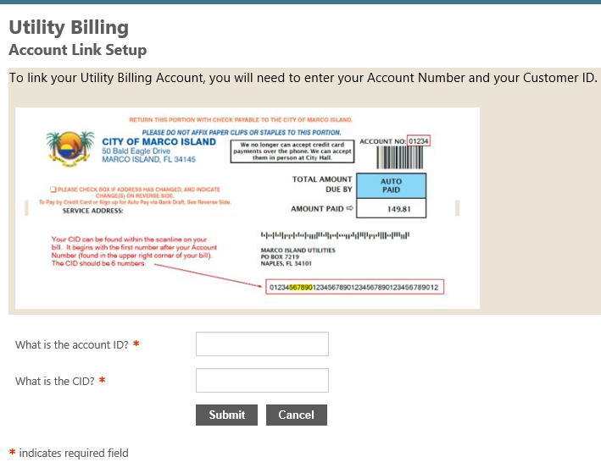
- Your account should now be listed under Utility Billing Accounts
- Click “Link to Account” to link another account, follow steps 8-11 above.

Paying Online
After you have gone through the steps to register and link your account
- Click on your account number (number in blue)
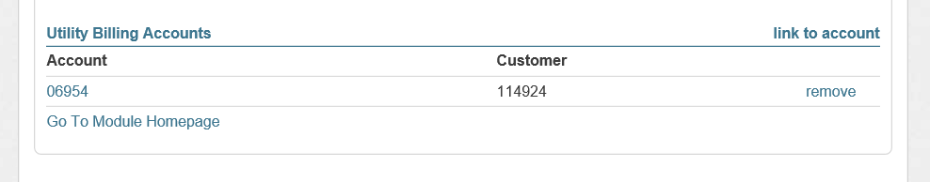
- In the “Your Current Balance” field click “Pay Now”
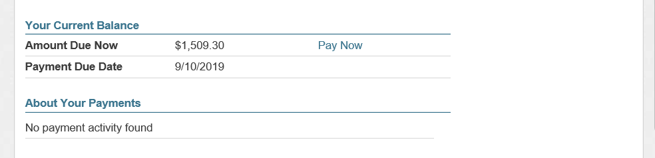
- Check off the bill(s) you wish to pay then click “Pay”
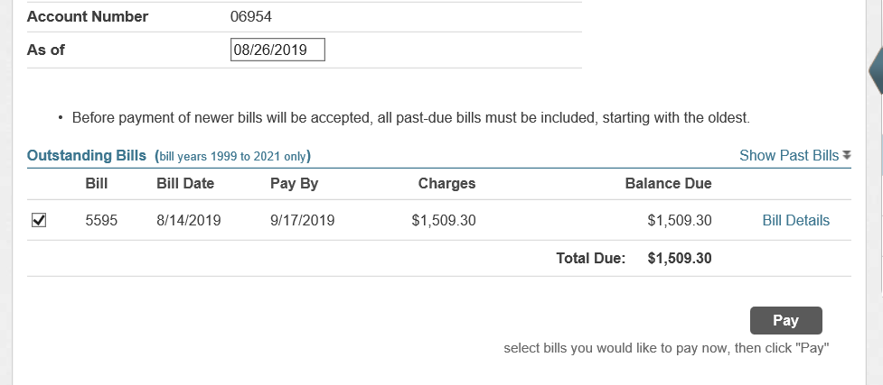

- Select your Payment Method – Credit Card or eCheck
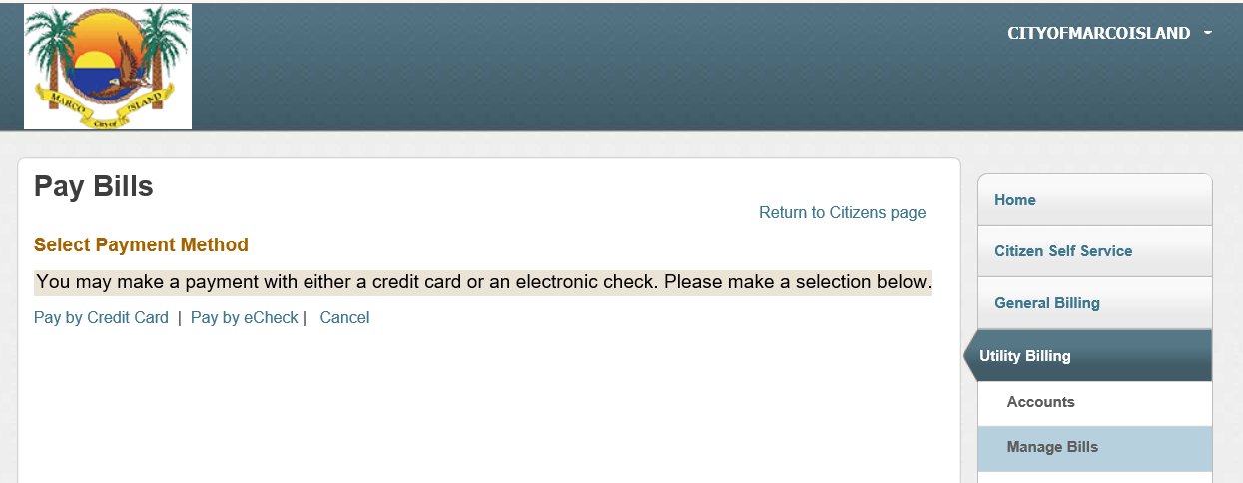
- Enter the amount you wish to pay into the Payment Amount field.
- Click Continue
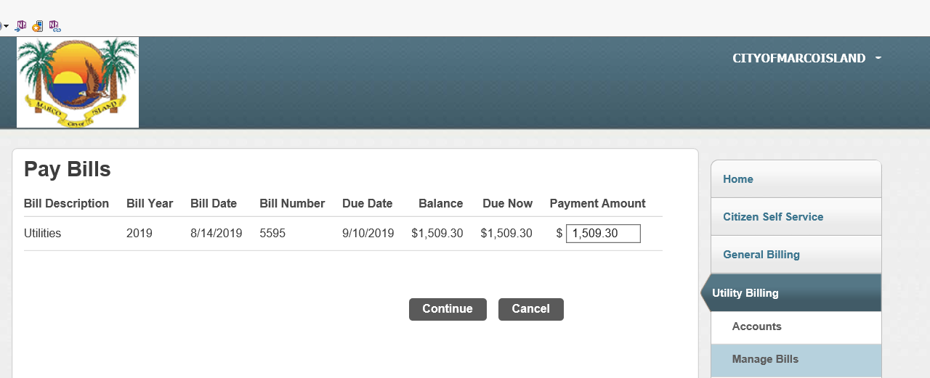

- Enter your Billing Information and click Make Payment to move on to enter your credit card or bank information for eChecks.
