
Meeting Date: October 16, 2017
To: City Council
From: Chief Al Schettino
Through: Guillermo Polanco, Interim City Manager
Re: August 2017 Monthly City Council Report
______________________________________________________________________________________________________________________________________
Community Events

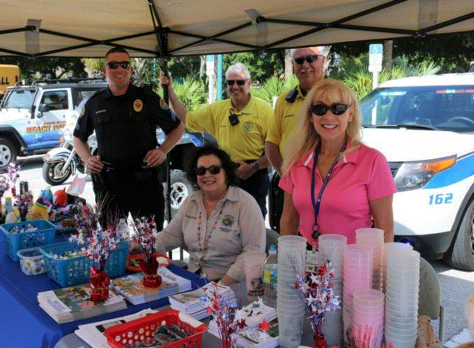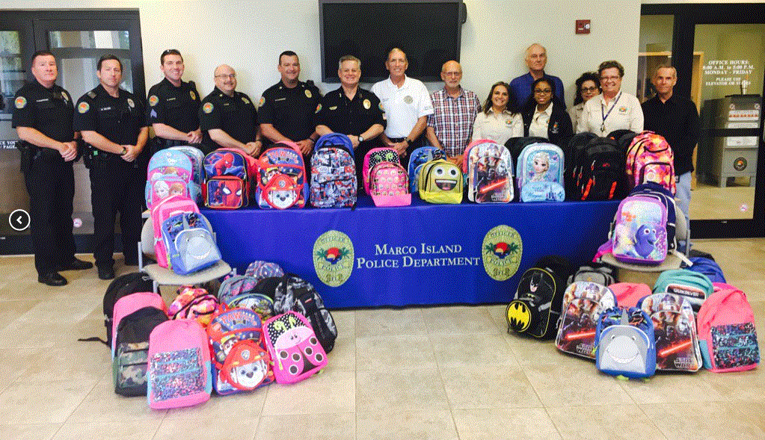

MIPD’s booth at Marco Island’s 20th Anniversary Celebration on The Marco Island Police Department once again collected back to school August 28. supplies for the Shelter for Abused Women & Children’s Give Back
Fill-A-Pack annual drive.

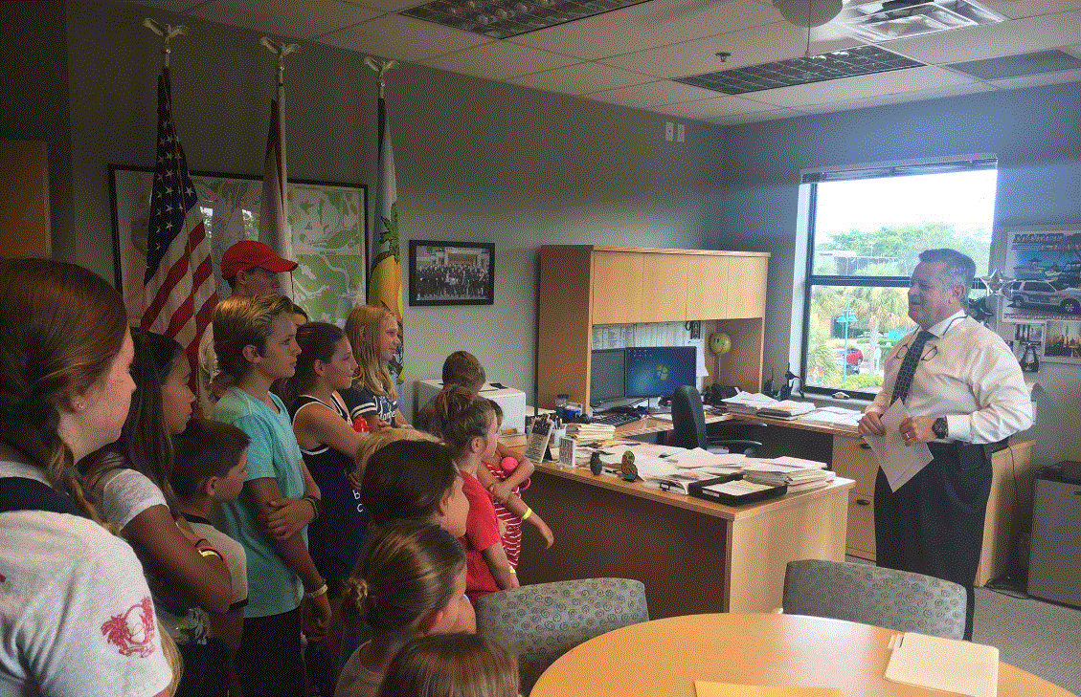
MIPD Officers Smith, Howell & Ferris attended the funeral for two Chief Schettino spoke to Camp Mackle participants on August 9 during
Kissimmee Police Officers killed in the line of duty. Career Week.

COMMUNITY EVENTS

On Saturday, August 5, the Marco Police Foundation held their annual summer picnic for members of the Marco Island Police Department at St. Mark’s Episcopal Church.

MIPD Officers continued the ongoing and multi-year program in August to provide bicycle lights and helmets to citizens in need. Helmets were donated by the Knights of Columbus. Bike light kits were donated by the Marco Police Foundation and Officer Bill Miller. MIPD Officers encountered two bicyclists in August. Both had proper working head/tail lights.

Investigations

August 2017 Significant Case Information/Incidents:

- 400 S. Collier Blvd. in reference to a report of theft of firearm from suitcase. Case is inactive.
- 51 Bald Eagle Drive in reference to identification used to open a credit card out of state. Victim was educated and provided fraud prevention materials.
- 1264 Orange Ct. in reference to a worker on property being electrocuted and survived. Non-criminal. Case closed.
- 890 S. Collier Blvd. in reference to persons having rented a condo for a week. Upon arrival, persons were already staying there. Condo had just sold. Persons in the condo, or the new person, were notified. Civil matter. Case closed.
- 1180 Samoa Ave. in reference to Death Investigation. Non-criminal. Medical Examiner took possession of deceased. Case closed.
- 51 Bald Eagle Drive in reference to identification used to open credit cards out of state. Victim was educated and provided fraud prevention materials.
- 705 E. Elkcam Circle in reference to Burglary & Grand Theft. Six boats had GPS units stolen out of them. Investigation continuing. Working with Naples PD and CCSO on possible suspects.
- 339 Landmark St. in reference to Burglary and Theft from auto. Vehicle was unlocked. $100 was stolen from vehicle. Case is inactive.
- 2173 San Marco Road in reference to Burglary and Theft from auto. Vehicle was unlocked. $80 and iPhone were taken. Case is inactive.
- 10 Tampa Place in reference to Theft of fishing equipment from boat. Investigation is continuing.
- 113 Shorecrest Ct. in reference to home damaged by grandchildren during a party. No charges filed. Case closed.
- 1610 Copeland Drive in reference to Domestic Violence. No arrest. DCF was contacted. Children were on scene.
- 51 Bald Eagle Drive in reference to identification used to open credit cards out of state. Victim was educated and provided fraud prevention materials.
- 419 Nassau Ct. in reference to Domestic Violence. Verbal dispute. No charges filed.
- 500 S. Collier Blvd. in reference to Domestic Violence. Verbal dispute. No charges filed.
- 400 N. Collier Blvd. in order to assist other Agency. Information obtained about illegal pawn activity.
- 175 S. Barfield Drive in reference to Shoplifting. Two persons were stopped for shoplifting. No charges filed. Business just wanted them trespassed.
- 400 S. Collier Blvd. in reference to Sexual Battery. Investigation is continuing.
- 51 Bald Eagle Drive in reference to DCF Referral. Not criminal.
- 900 S. Collier Blvd. Male exposed himself. Investigation is continuing.
- N. Collier Blvd. & Seaview Ct. in reference to Grand Theft Auto. Four juveniles were arrested in a stolen vehicle. Detectives questioned suspects regarding two stolen vehicles and other car burglaries on Marco Island.
- 51 Bald Eagle Drive in order to assist other Agency. Fraud occurred in Minnesota. MN PD needed to identify a Marco Island resident who deposited money from their suspect. Subject was located and all information provided to MN PD.
- 1120 Martinique Ct. in reference to Domestic Violence. Verbal only. Not criminal.
- 600 Bald Eagle Drive in reference to DUI and crash with property damage. Subject was arrested. Video was obtained of traffic crash.
- 400 S. Collier Blvd. in reference to Criminal Mischief. Vehicle was keyed. No suspects or witnesses. Case closed.
- 560 S. Collier Blvd. in reference to reported Battery that occurred two months ago. Investigation is continuing.
- 400 S. Collier Blvd. in reference to Battery. Subject was arrested. MIPD working with Marriott LP to obtain video.

Four sex offender registrations were completed on August. Four persons are registered on Marco Island. Notifications were made to schools, parks, YMCA, library and beach facilities.

PERSONS ARRESTED: 31
OTHER AGENCY ASSISTS: 2
WARRANT HOT LIST CHECKS: 211
DCF REFERRALS/FOLLOW-UPS: 1
SUBPOENA REQUESTS: 3
WARRANT REQUESTS: 2
WARRANT ARRESTS: 0
QUARTERLY SEX OFFENDER CHECKS: 4
FLYERS/BULLETINS: 6

AUGUST 2017 CASES

OPEN 4
CLOSED 46
CLEARED 23
INACTIVE 4
PENDING 0

TOTAL 81

Crime & Incident Report Highlights: 8/15/17 – 9/15/17

DATE & TIME: 08/19/2017
INCIDENT: Aggravated Assault
Officers were dispatched to a residence located on Greenbrier Street in reference to a juvenile male causing a disturbance. The juvenile male was arrested for Aggravated Assault and was transported to the Naples Jail Center.

DATE & TIME: 08/20/2017
INCIDENT: Illegal Possession of Marine Resources
A Marine Officer was navigating through the waters of the ABC Islands in Sanctuary Sound and witnessed a male fishing in the protected area. The male boater was given a Summons to Appear for Court for Illegal Possession of Marine Resources.

DATE & TIME: 08/22/2017
INCIDENT: Habitual Traffic Offender - Felony
An Officer conducted a traffic stop on a vehicle for speeding. The male driver was arrested for Driving while License Suspended – Habitual Violator and Possession of Marijuana. He was transported to the Naples Jail Center.

DATE & TIME: 08/25/2017
INCIDENT: Possession of a Controlled Substance - Felony
An Officer conducted a traffic stop on a vehicle for an equipment violation. The male driver was arrested for Possession of a Controlled Substance and was transported to the Naples Jail Center.

DATE & TIME: 08/28/2017
INCIDENT: DUI
An Officer conducted a traffic stop on a vehicle failing to maintain a lane. The female driver was arrested for DUI and was transported to the Naples Jail Center.

DATE & TIME: 08/30/2017
INCIDENT: Stolen Motor Vehicle
An Officer conducted a traffic stop on a vehicle for speeding. The juvenile male driver and three juvenile male passengers were arrested for stealing a vehicle in Collier County. The three juveniles were transported to the Naples Jail Center.

DATE & TIME: 08/31/2017
INCIDENT: DUI
Officers were dispatched to the business of 7-Eleven located on Bald Eagle Drive in reference to a vehicle that hopped a curb and struck the Red Box video-dispensing machine on the property. The male driver was arrested for DUI and transported to the Naples Jail Center.

DATE & TIME: 09/02/2017
INCIDENT: DUI
Officers were dispatched to the business of Marco Polo in reference to a female subject causing a disturbance, who had since left the scene. The female was located and arrested for DUI. She was transported to the Naples Jail Center.

DATE & TIME: 09/03/2017
INCIDENT: Grand Theft
Officers were dispatched to a construction site located on Bald Eagle Drive in reference to a suspicious male and female removing property without permission. The male and female subjects were arrested for Grand Theft and transported to the Naples Jail Center.

DATE & TIME: 09/12/2017
INCIDENT: Discharging Firearm in Public
Officers were dispatched to a residence in the area of San Marco Villas in reference to a male subject discharging his firearm from his home. The male was arrested for Discharging a Firearm in Public and was transported to the Naples Jail Center.
Marine Report
In August, our two Marine Officers assisted with road patrol coverage and staffing needs due to training events or members on leave. Marine Officers inspected vessels in Smokehouse and Factory Bays in reference to City of Marco Island Ordinance 327.53 (marine sanitation devices): 4 vessels were found to be in compliance, 3 additional vessel inspections were attempted, however the vessels were found to be unattended.

Extra Patrols | 16
Vessel Stop Citation | 5
Disabled Vessel | 4
Vessel Stop Written Warning | 2
Reckless Vessel | 2
Suspicious Person | 1
Animal Assist (Manatee Rescue w/ FWCC) | 1
Marine Rescue Team | 1
911 | 1
Fire | 1

Beach Report
Total Beach Patrol Hours = 268 Hours

Total Beach Patrol Events = 99 events including Community Policing contacts or events.

Details -
Provided Directions / Information | 8
Vessel Operation Verbal Warning | 4
Assisted with Trash Pick-up | 3
Bike on Beach Verbal Warning | 3
Medical Call | 3
Youth COPS Activity | 2
Reckless Vessel | 2
911 Cell (Accidental) | 2
Glass on Beach Verbal Warning | 2
Dog on Beach Verbal Warning | 2
Suspicious Person | 1
Animal | 1
Disabled Vessel | 1



