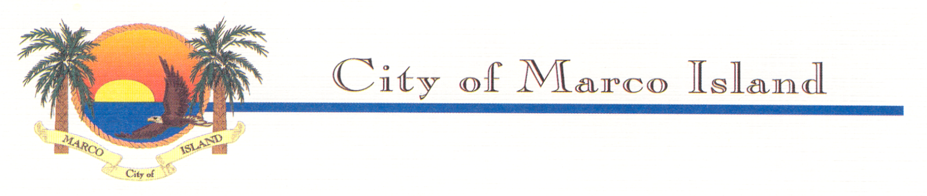

CITY OF MARCO ISLAND NOTIFICATION OF PUBLIC HEARINGS TO
CONSIDER ADOPTION OF ORDINANCE TO IMPLEMENT CHANGES IN THE WATER AND SEWER IMPACT FEE STRUCTURE, INCREASES TO WATER AND SEWER IMPACT FEES, AND METER / SERVICE INSTALLATION CHARGES

Pursuant to Section 180.136, Florida Statutes, the City of Marco Island (“City”) is providing notification of upcoming public hearings to be held by the City Council to consider the adoption of an ordinance to implement changes in the City’s water and sewer impact fee structure, increases to water and sewer impact fees, and City water meter service and installation charges. Impact fees are a one-time charge for new connections to the City’s water and sewer systems and are designed to recover the cost of existing infrastructure and expansion of improvements to infrastructure to serve the community. The adjustments will become effective upon approval of the ordinance. Public hearings on this matter will be held by the City Council on Monday, April 24, 2023, and Monday, May 8, 2023, at the Dr. Fay and Bedford Biles Community Room, 51 Bald Eagle Drive, Marco Island, FL 34145, beginning at 5:30 P.M. The impact fee study, the proposed ordinance which includes revisions to the City’s impact fee structure, and impact fee rates, as well as City water meter service and installation charges can be reviewed at the Marco Island City Clerk's office, or via the following link:
https://www.cityofmarcoisland.com/watersewer/page/proposed-impact-fee-ordinance

